Schedule Changes

Overview
The "Publish Date and Time" feature within Schedule Changes in Petpooja allows restaurant owners or managers to schedule when specific changes should go live on their POS system. This adds an extra layer of automation, ensuring that updates to the menu or pricing are pushed live at the right time without manual intervention.

Path : billing.petpooja.com > Menu > Menu & Discount >Base Menu >Schedule Changes
Outletwise_Link: https://menu.petpooja.com/menus/menu_new/all/1/

Step 1 : Billing.petpooja.com in Steps to reach Schedule Changes: Open your browser and go to billing.petpooja.com.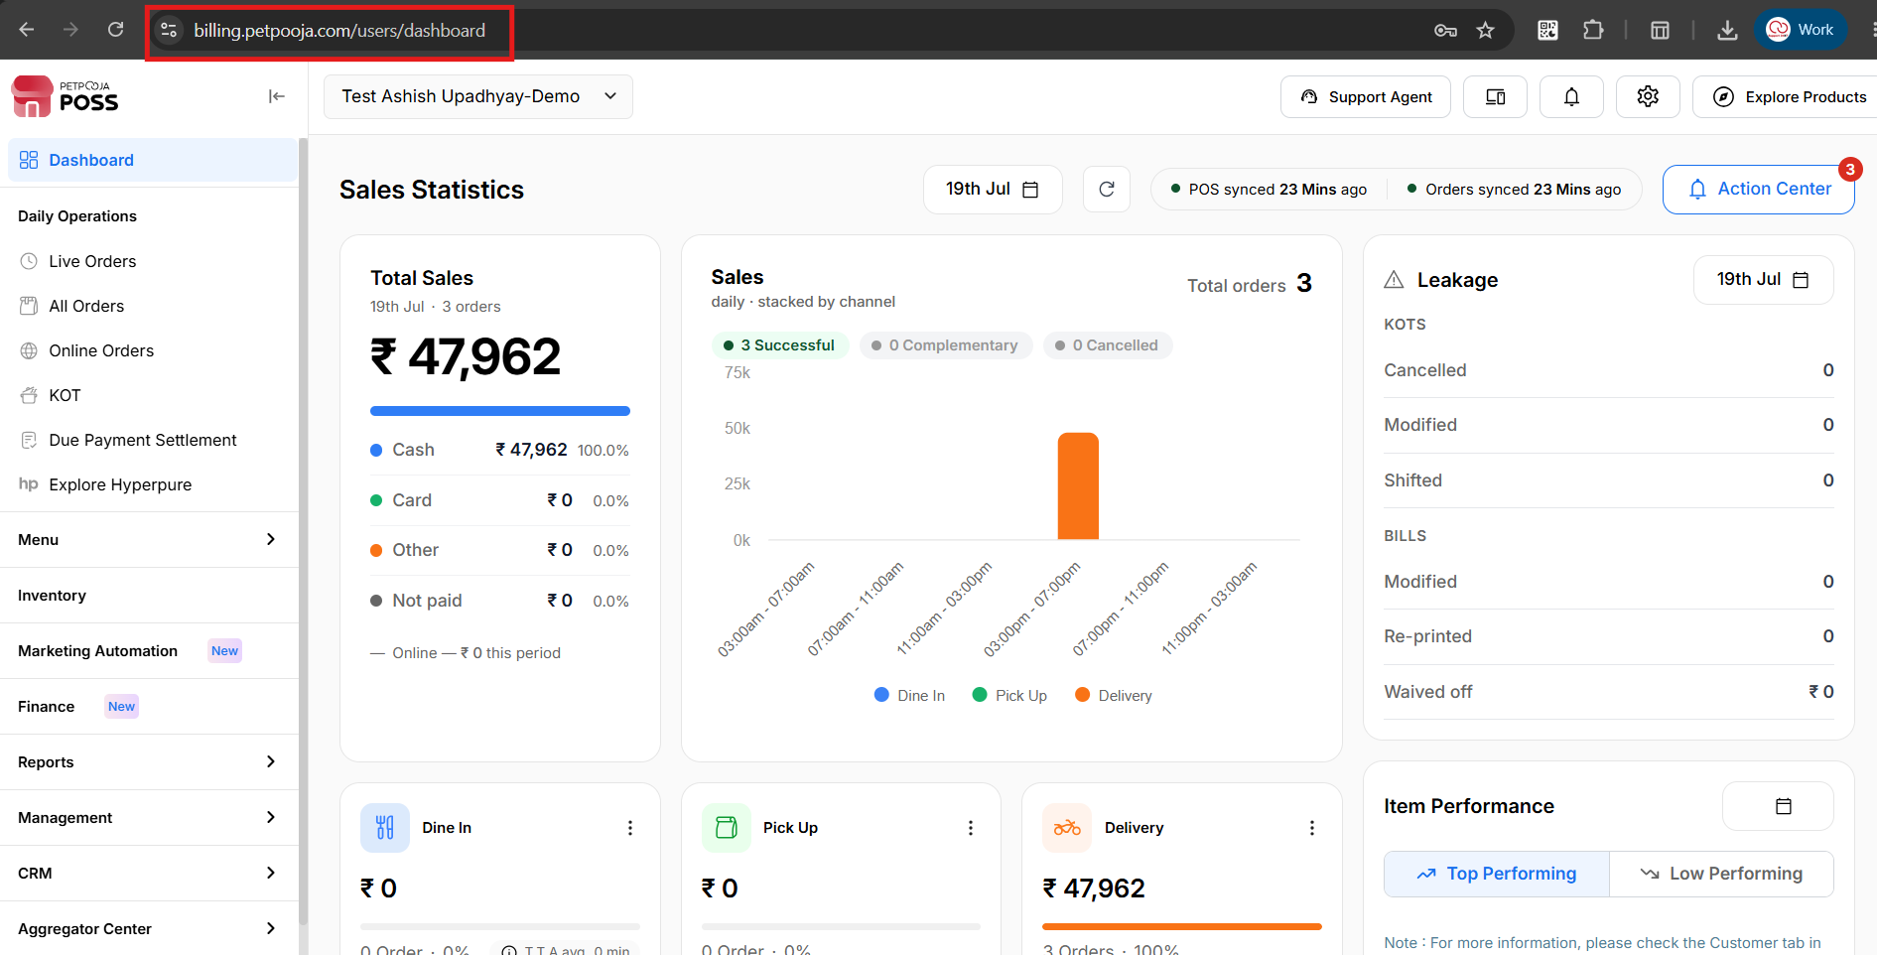
{Image Name: PetPooja Dashboard,
Description: The highlighted URL indicates that this is the billing.petpooja.com. Here is an image of Step 1 billing.petpooja.com in Steps to reach Schedule Changes.}
Step 2 : Menu in Steps to reach Schedule Changes : Click on the Menu section from the dashboard.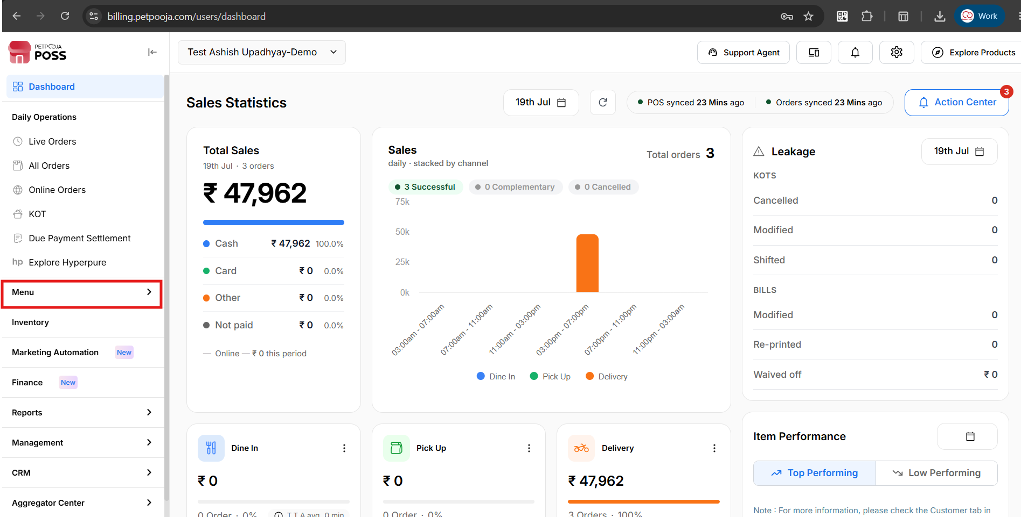
{Image Name: PetPooja Menu,
Description: The highlighted section indicates the "Menu" option on the left-side panel of the PetPooja dashboard. Here is an image of Step 2 Menu in Steps to reach Schedule Changes.}
Step 3 : Menu & Discount in Steps to reach Schedule Changes : Inside the Menu section, click on Menu & Discount.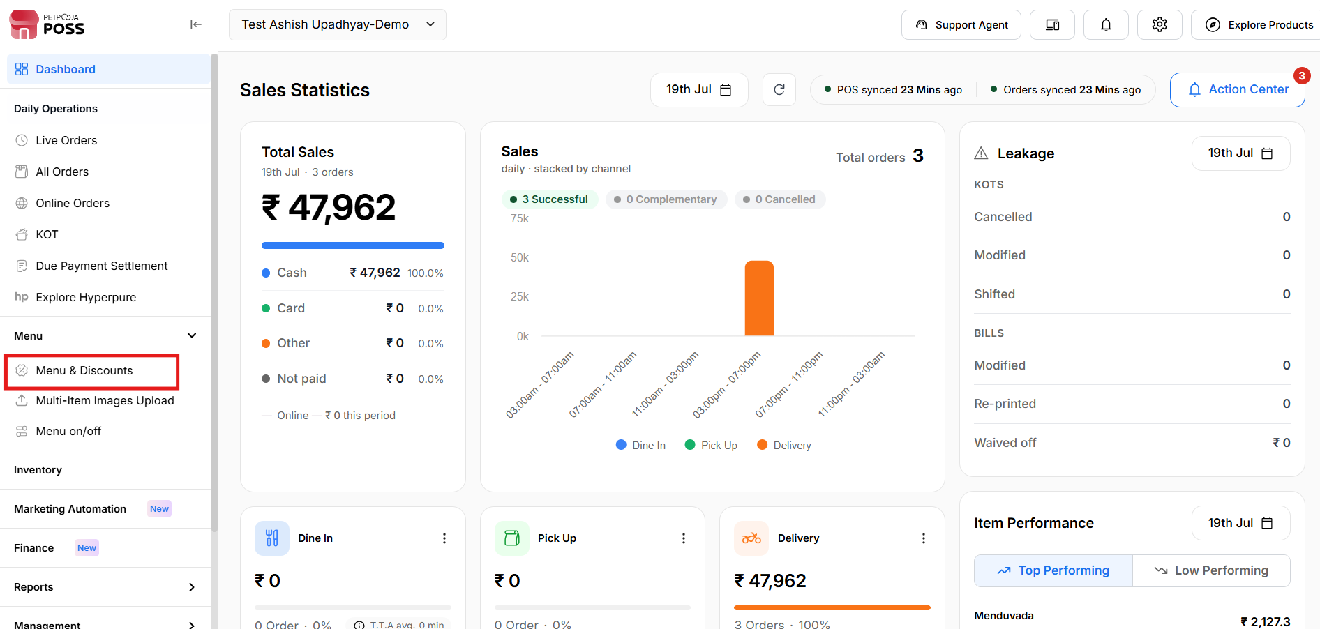
{Image Name: PetPooja Menu & Discount,
Description: The image shows the "Menu & Discount" section within the "Menu Management" page.Here is an image of Step 3 Menu & Discount in Steps to Reach Schedule Changes.}.

Step 4 : Schedule Changes in Steps to reach Schedule Changes : Inside Menu & Discount, go to Schedule Changes, then click on Base Menu.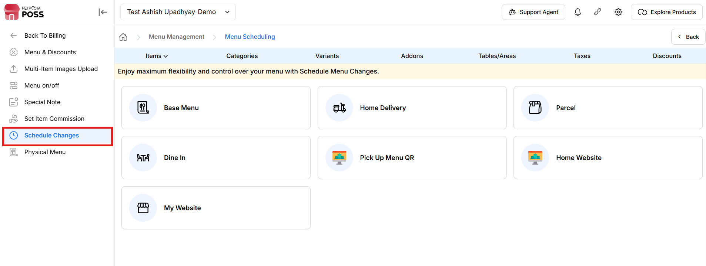
{Image Name: Schedule Charges,
Description: The highlighted panel on the left shows the "Schedule Changes" section under Menu & Discount.Here is an image of Step 4 Schedule Charges in Steps to Reach Schedule Changes.}

Key features of Schedule Change :
Outletwise_Link: https://menu.petpooja.com/menus/menu_new/all/1/
Base Menu : After The Click On “Schedule Changes” Then Click On The “ Base Menu”.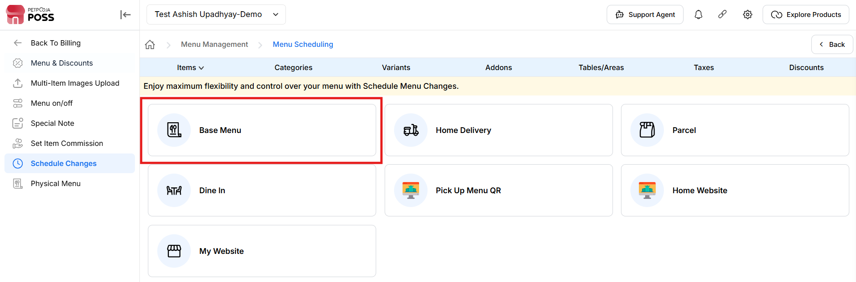
{Image Name: PetPooja Menu Scheduling Options,
Description: Here is an image showing the "Menu Scheduling" interface in PetPooja, where users can select from various menu types such as Base Menu, Home Delivery, Parcel, Dine In, Zomato, and Swiggy for scheduling changes.}

Benefits (Schedule Changes):
Outletwise_Link: https://menu.petpooja.com/menus/menu_item_list_new/
- (Benefits) 100% Automation: No human action needed at the time of publishing.
- (Benefits) Timely Updates: Ensure promotions and changes go live at the right moment.
- (Benefits) Reduced Errors: Prevent missed updates or manual entry mistakes.
- (Benefits) Improved Planning: Great for pre-scheduling marketing campaigns or seasonal menus.
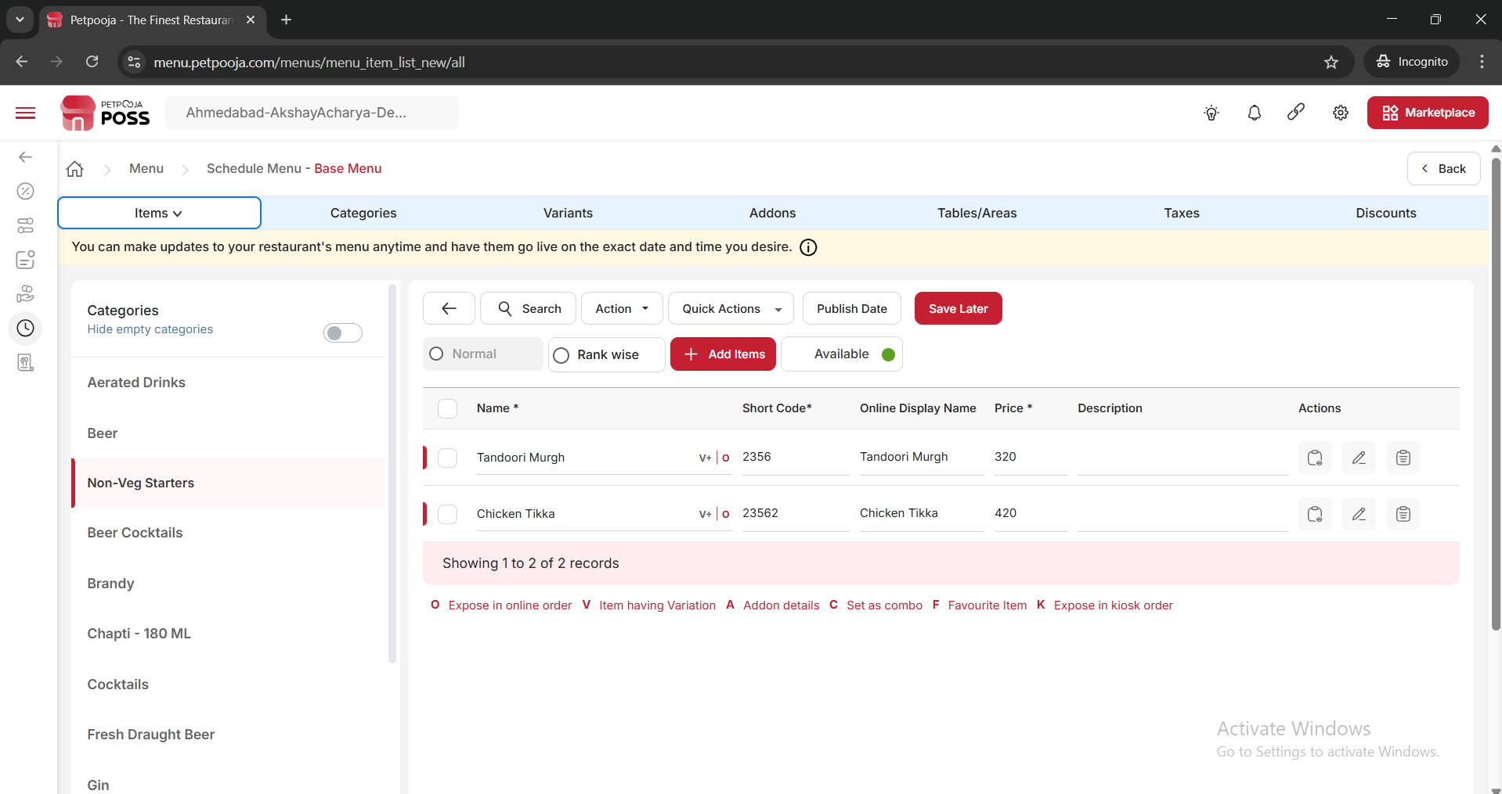
{Image Name: PetPooja Base Menu Items View,
Description: Here is an image showing the "Base Menu" item list in PetPooja with categories, item details such as name, short code, price, and online display name, along with options to add, edit, or reorder items rank-wise.}
- (Schedule Changes) To change the item schedule, you need to select the categories first and then select the specific items.
- (Schedule Changes) To publish all items, you need to select the 'Select All' option. To publish a specific item, you need to individually select that particular item.

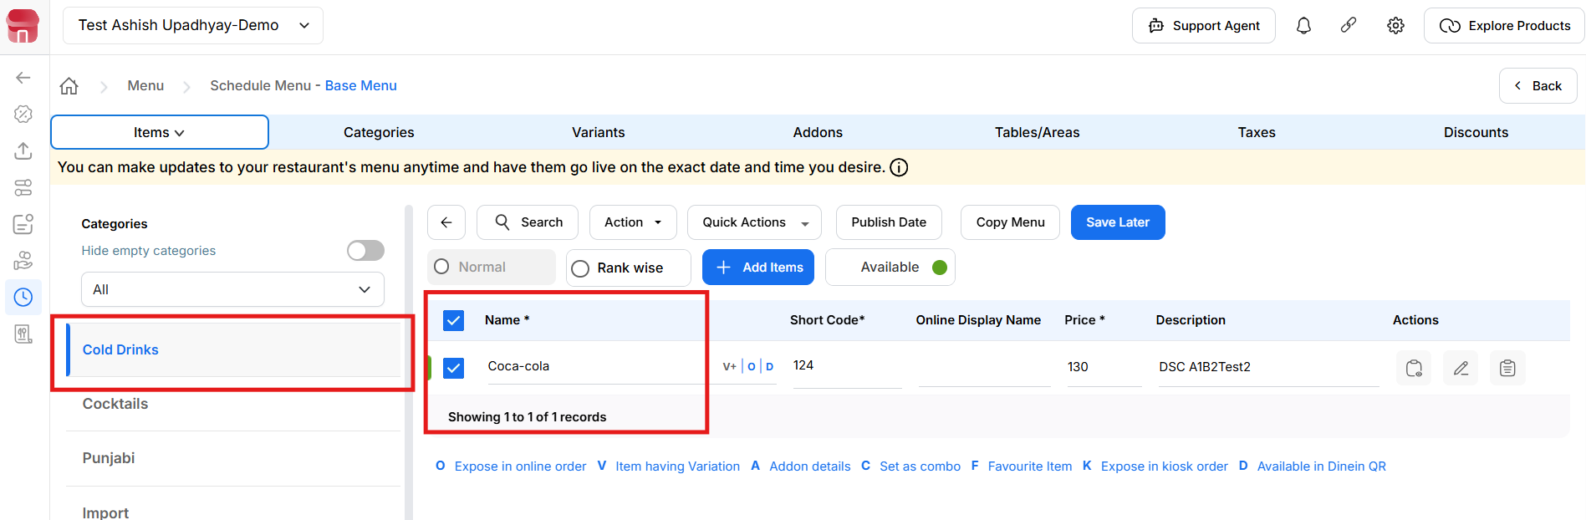
{Image Name: PetPooja Non-Veg Starters Selection,
Description: Here is an image showing selected items under the “Non-Veg Starters” category in the PetPooja Base Menu. The items “Tandoori Murgh” and “Chicken Tikka” are ticked for bulk actions.}
(Schedule Changes) After selecting the items, click on the 'Publish Date' button to schedule the desired date and time for publishing.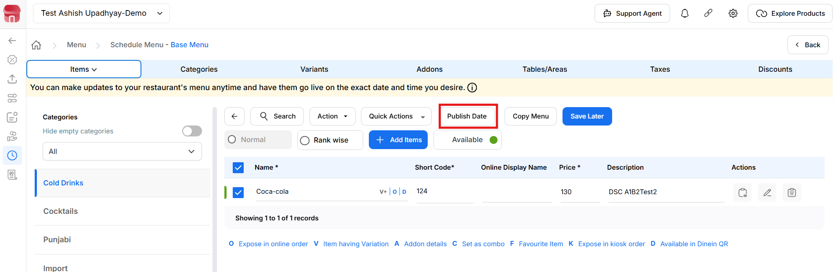
{Image Name: PetPooja Menu Publish Option,
Description: Here is an image showing the “Publish Date” option highlighted in the PetPooja Base Menu screen. Two items, “Tandoori Murgh” and “Chicken Tikka,” are selected for publishing or scheduling.}
(Schedule Changes) After clicking on the 'Publish Date' button, the options to select date and time will be displayed.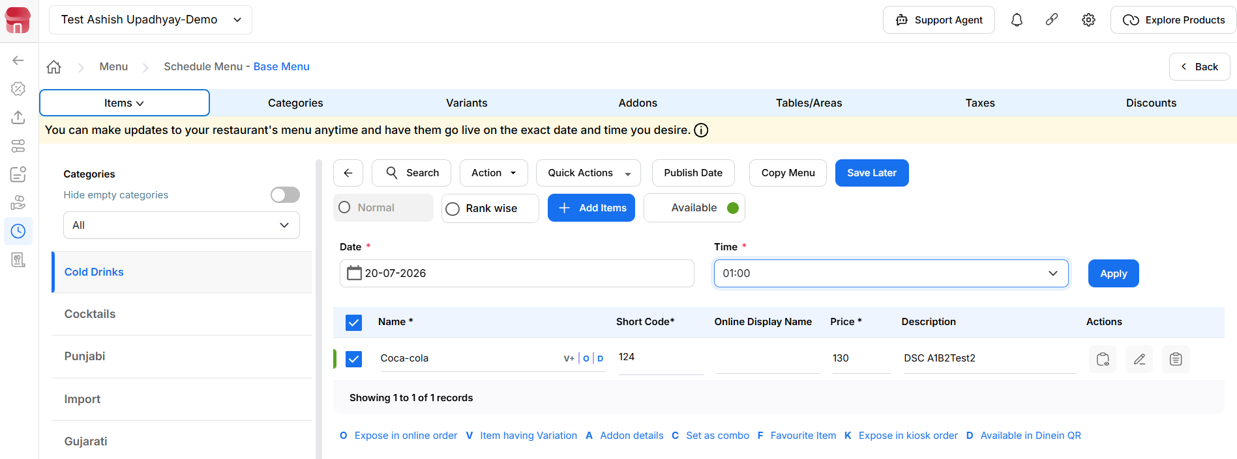
{Image Name: PetPooja Menu Schedule Date-Time,
Description: Here is an image showing the date and time scheduling panel in the PetPooja Base Menu. “Tandoori Murgh” and “Chicken Tikka” are selected, with a publish date set to 19-04-2025 and time to 01:30.}
(Schedule Changes) To add the date, you need to click on the date field.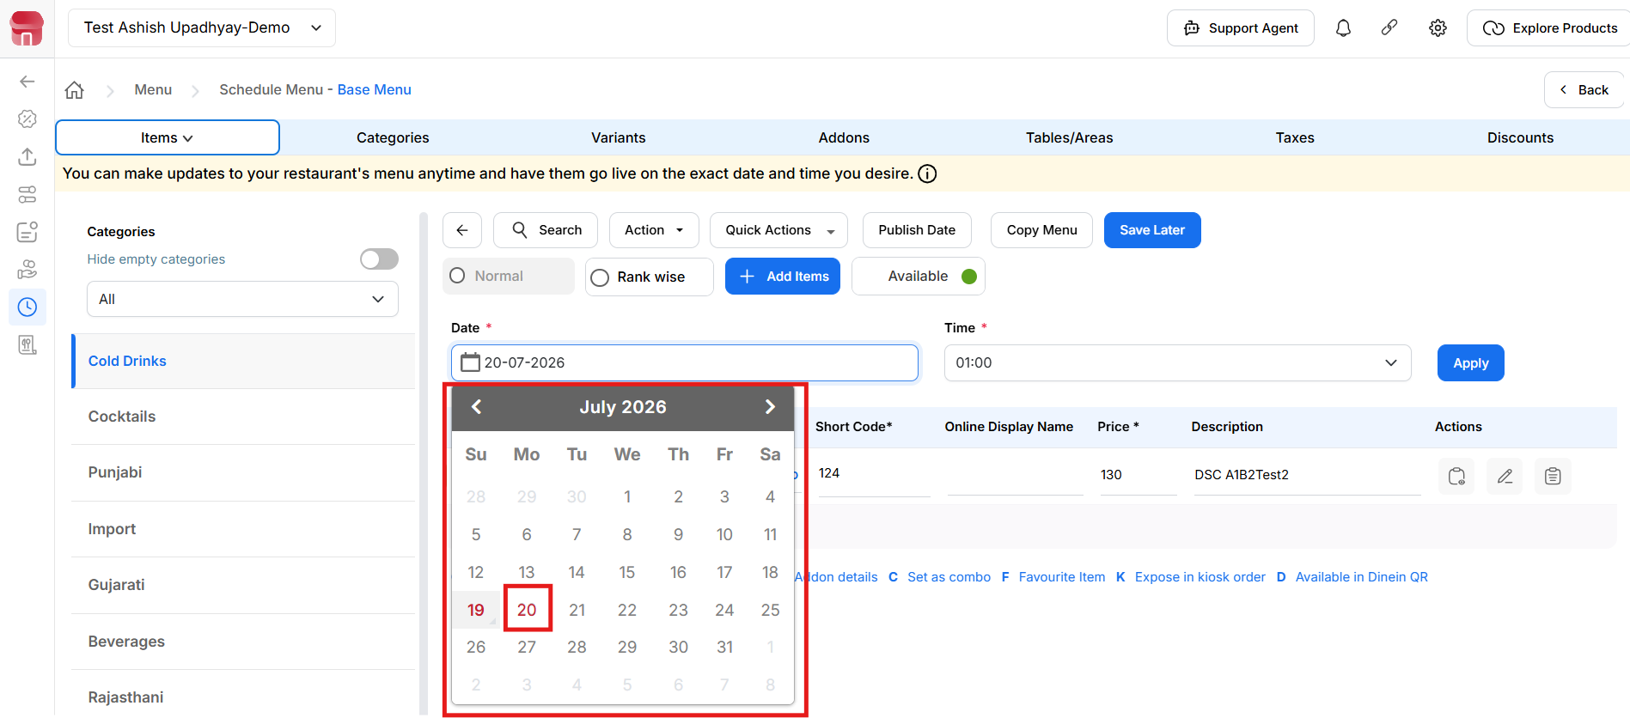
{Image Name: PetPooja Menu Date Picker,
Description: Here is an image showing the calendar date picker in the PetPooja Base Menu scheduling panel. The selected date is highlighted as 21st April 2025 for scheduling menu item updates.}
(Schedule Changes) Then, to select the time, click on the time field and choose the desired time.After selecting the date and time, click on the 'Apply' button.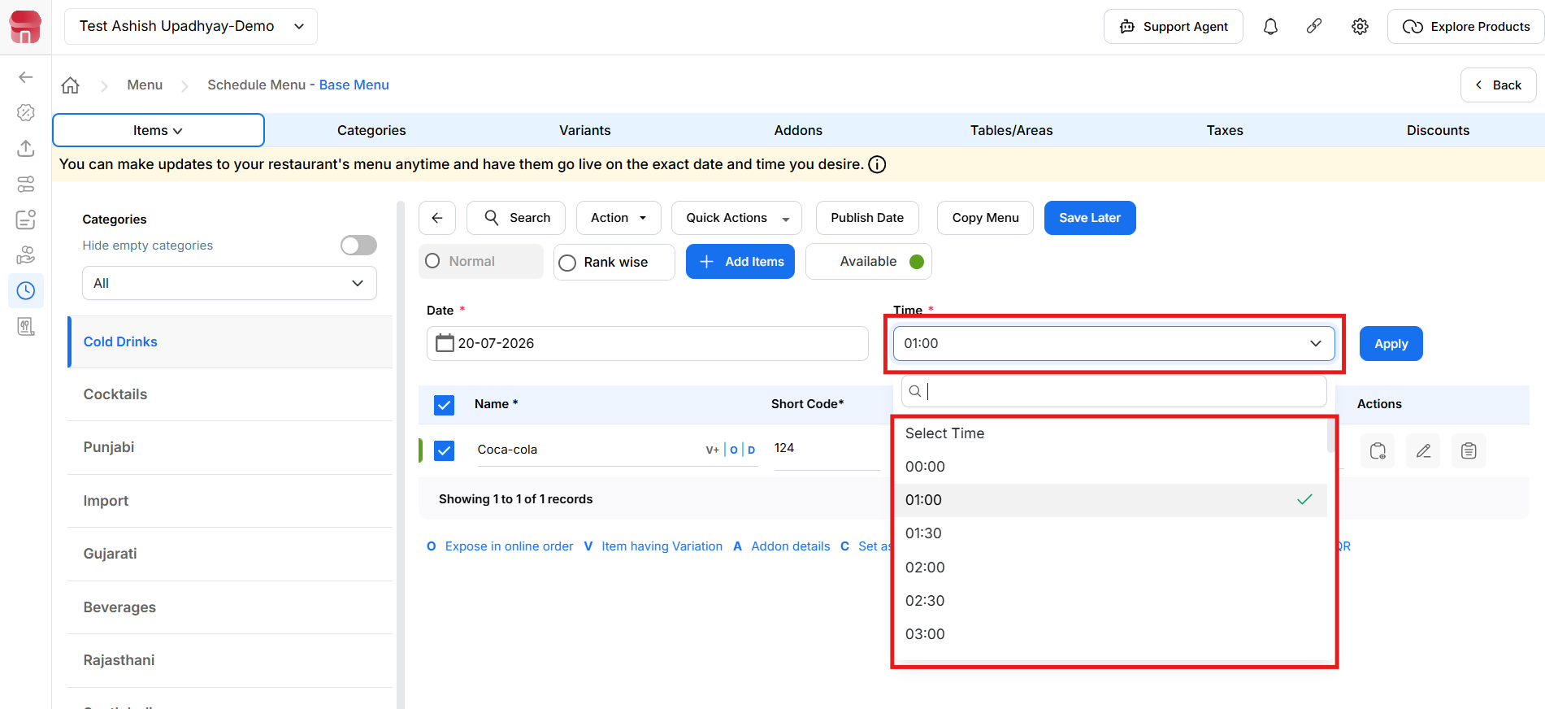
{Image Name: PetPooja Menu Time Selector,
Description: Here is an image showing the time selection dropdown in the PetPooja Base Menu scheduling panel. The time "01:30" is selected for publishing the changes to the listed menu items.}
(Schedule Changes) To remove the publish date and time, select the item name.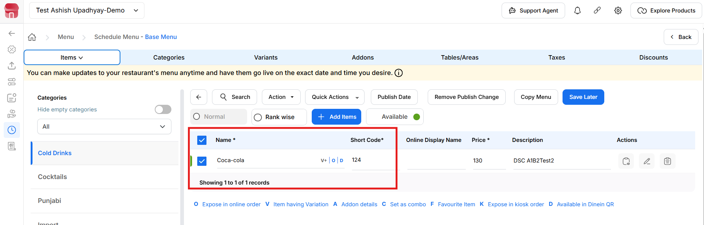
{Image Name: PetPooja Menu Scheduling Overview,
Description: Here is an image showing the scheduled menu items "Tandoori Murgh" and "Chicken Tikka" set to go live on 21-04-2025 at 01:30 in the PetPooja Base Menu panel}.
(Schedule Changes) Then, click on the 'Remove Publish Change' button to complete the removal process.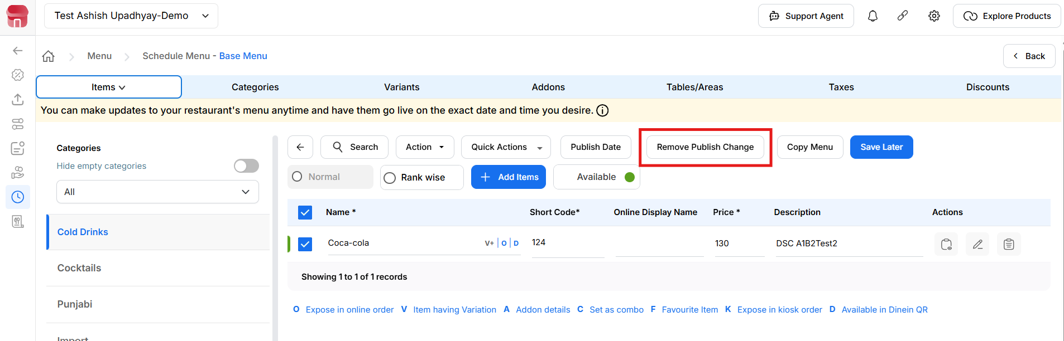
{Image Name: PetPooja Remove Publish Change,
Description: Here is an image showing the “Remove Publish Change” option highlighted in the PetPooja Base Menu panel, allowing users to cancel the scheduled publishing of selected menu items.}
Note: Item Scheduling is not available for Swiggy and Zomato. This feature is only available for Offline (POS or Billing Application).
Note (Schedule Changes): If any changes are made in the Schedule Changes from the dashboard, manual sync is mandatory in POS/Billing Application.
Note (Schedule Changes): if there are any changes to Schedule Changes from the dashboard for online,you have to do the menu trigger because it is mandatory.

